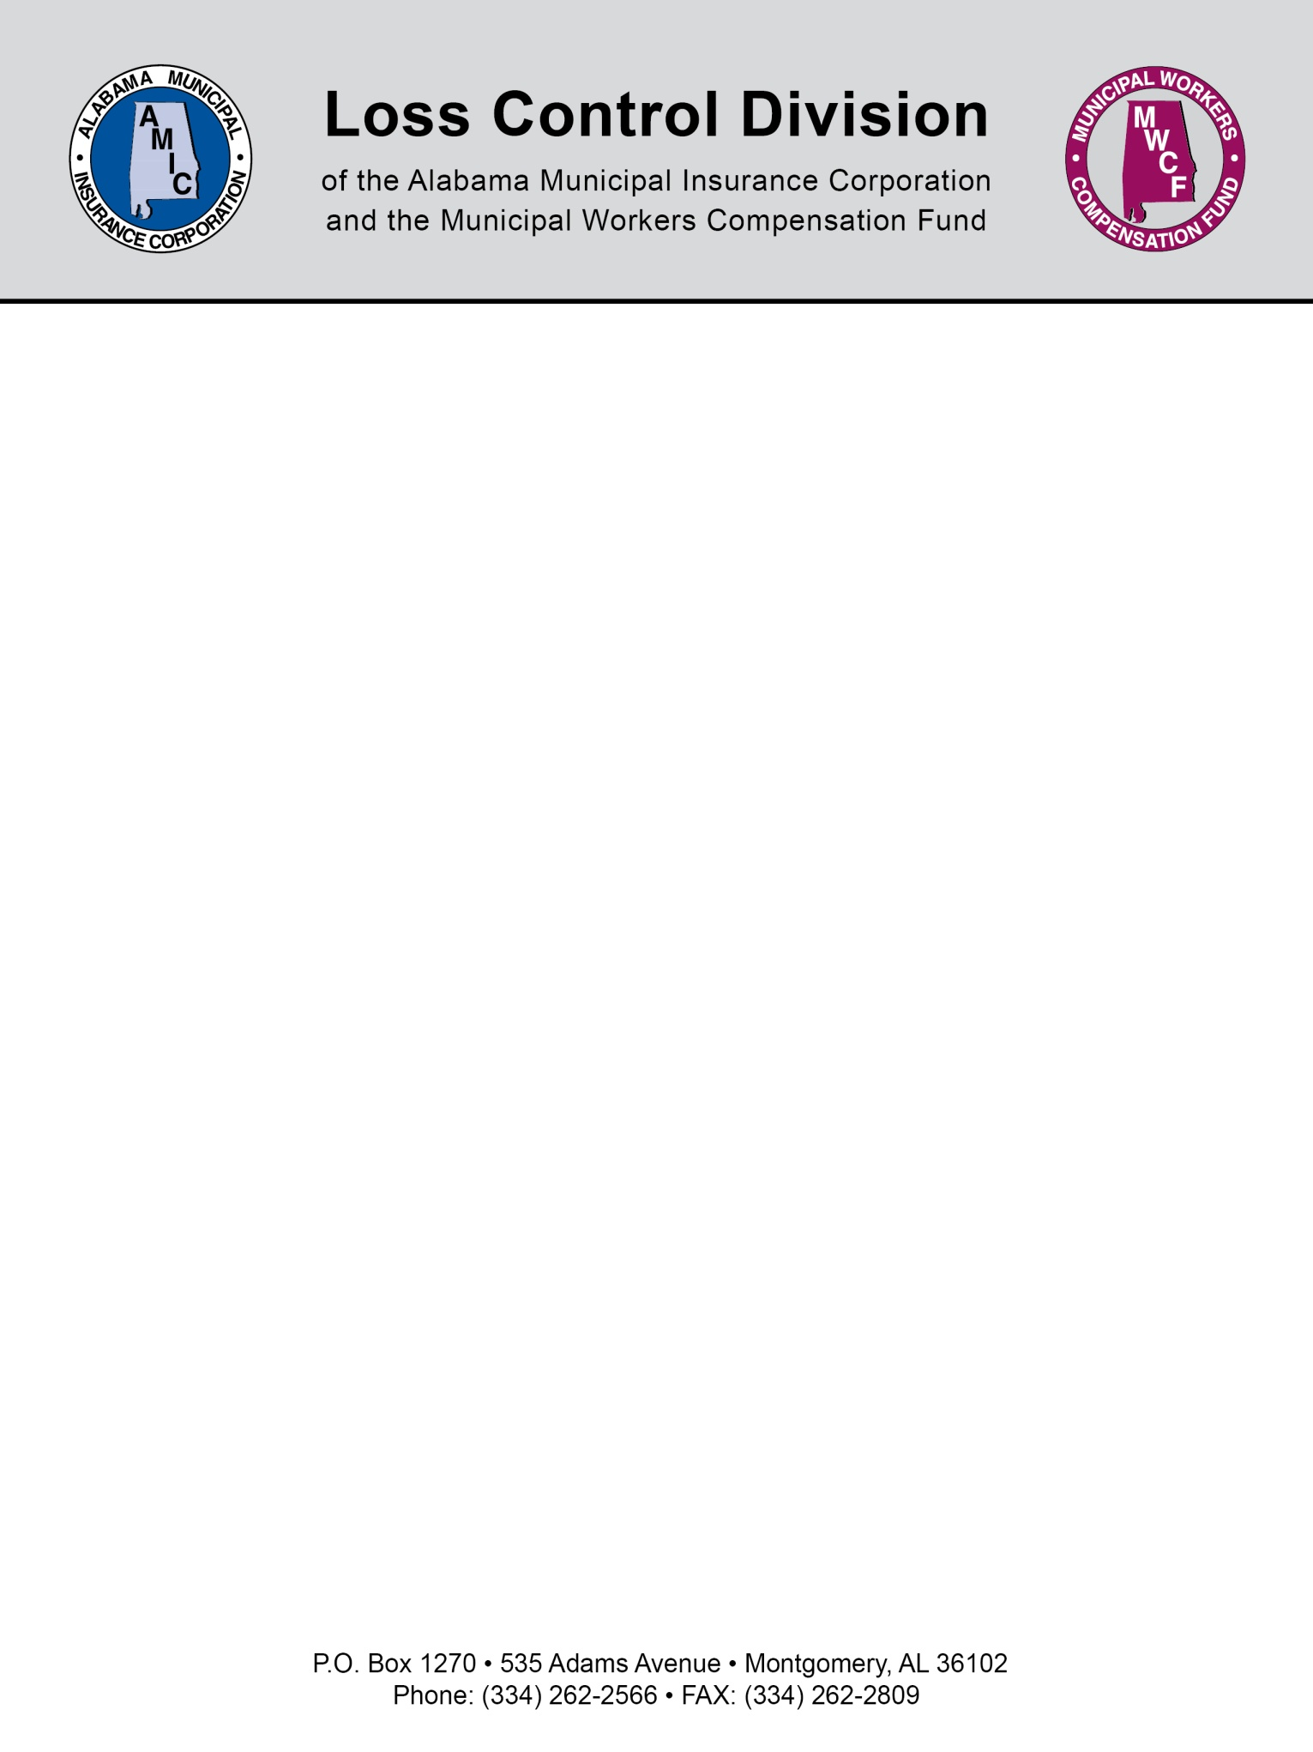

ACCIDENT INVESTIGATION PROGRAM GUIDELINES

No safety program can be effective without good accident investigation procedures. It is important that each accident be fully investigated to determine not only the cause of the accident, but also the corrective action to be taken to prevent future incidents. Follow these guidelines to ensure a complete and effective accident investigation program.

WHY
Accidents are caused by an unsafe act, an unsafe condition, or both. In order to prevent repeating an accident, we must find and eliminate the unsafe act or condition which caused it. A complete and thorough investigation is the only way to uncover all information which may help prevent a similar mishap. Every accident, regardless of size or severity, must be investigated and an earnest attempt be made to discover and eliminate the unsafe act or condition causing it.

WHO
The investigation should be conducted by the immediate supervisor of the injured employee, if possible, for the following reasons:

1. The person in direct charge of the injured employee is in daily contact with this employee and their work habits.
2. The immediate supervisor has the responsibility to see that his employees are doing their work in a safe and efficient manner. Therefore, he accepts responsibility of any accident that happens to an employee under his charge.
3. Involvement in the investigation of every accident involving an employee in his charge will arouse the safety consciousness of the supervisor.

All supervisors should receive training in accident investigation procedures.

WHEN
In the event of an accident involving an injury, the injured person should obtain needed medical attention first and foremost.

The next important step is to report the injury to your worker's compensation insurance carrier. Your insurance agent can provide you with the appropriate forms. They include the State issued First Report of Injury form and the Supervisor's Report. The First Report of Injury should be sent to your insurance carrier, by mail or fax, within 48 hours of the accident.

The accident investigation should then be conducted as soon after the accident and notification of the insurance carrier as possible. This will make it easier to obtain all necessary information as accurately as possible.
HOW

These steps are to be used as a guideline in investigating your accidents.

I. Gathering the Facts:

Identify and document all observable facts.

1. Collect basic data such as location, time, machines or tools involved, witnesses, etc.
2. Note environmental conditions such as slippery floors, lighting, noise, dust, vapors, etc.
3. List equipment, machinery, and tools used before and during the accident, including type of machine, guarding, maintenance schedule, and possible defects.
4. Identify safety equipment and devices, such as personal protective equipment, ventilation, and machine guarding.

Interview the injured employee(s) involved.

1. Put the employee at ease by explaining that the purpose of accident investigation is accident prevention, not to place blame.
2. Conduct the interview at the scene of the accident, but as privately as possible. This helps the employee to recall the accident and at the same time helps to paint a picture of what happened.
3. Ask the employee to tell you in their own words exactly what happened. Do not interrupt or ask for more details at this time.
4. After the employee has given his/her description of the event, ask appropriate questions that focus on cause. Avoid leading questions.
5. Ask the employee how the accident could have been prevented.

Interview any witnesses to the accident.

Follow the same procedure for interviewing the injured employee. There should seldom be a case where there are no witnesses. If there is more than one witness, interview each person separately so that there is no peer pressure.

Utilize other sources of relevant information. Consider the following questions.

1. Was the injured employee in good health when arriving at work that day?
2. What was the employee doing just before and at the time of the accident?
3. Was the injured employee carrying out their normal duties?
4. Was the injured employee properly instructed as to how to perform their duties? Check training records. And if so, was the employee following these instructions?
5. Did another employee contribute to the accident?
6. If a machine or tool was involved, was it in good condition and/or being used for the purpose for which it was intended?

II. Recording the accident.

As stated earlier, the State issued First Report of Injury is used to report Worker's Compensation Claims to your insurance carrier only. It is not intended for use as accident investigation, although it can be recorded along with the Accident Investigation.

There are two important forms in Accident Investigation. One is the Detailed Investigation Report to be filled out after the investigation of every accident and near miss. The second form is a comprehensive Accident and Injury Report. This is a log of all accidents to aid in spotting trends and problem areas. See an example of both reports attached (Pages 7-10).

III. Cause and Corrective Action

Identify causes by reviewing the facts.
The many possibilities of accident cause can be overwhelming. Review the attached pages titled Unsafe Acts and Conditions (page 4) and Why People Do Unsafe Things (page 5) to facilitate thinking of likely causes. Also use of the following questions can help in deciding on the cause of the accident.

1. Employee selection: Was the right person chosen for the job? Did he/she have the appropriate qualifications?
2. Employee training: Was the person properly trained for the job being performed at the time of the accident?
3. Employee supervision: Was the employee properly supervised?
4. Equipment selection: Was the appropriate piece of equipment being used?
5. Equipment maintenance: Was the equipment properly maintained and in good working condition?

Establish and implement corrective action.

1. Establish the appropriate corrective action for each cause of the accident.
2. Implement the corrective action. This is the responsibility of management as part of their commitment to providing a safe workplace. It can be assigned to any employee that is capable of completing the task and needs to have a time limit of implementation. Management needs to follow up after the allotted time has expired to ensure corrective action has been implemented.
3. Communicate the corrective actions to the injured employee and all other employees affected by the change.

Examples of Unsafe Acts and Conditions

Examples of Unsafe Acts:
- Failure to give proper signal before starting equipment
- Failure to lock or block or secure equipment when necessary
- Failure to shut off equipment before oiling, cleaning, or adjusting
- Feeding or supplying material into equipment too rapidly
- Throwing material, tools, or equipment instead of passing or carrying them
- Jumping from vehicles or platforms
- Failure to use protective devices or to use them in a proper manner.
- Using defective equipment or tools
- Using hands instead of equipment
- Gripping objects insecurely or taking wrong hold
- Failure to use safety devices
- Overloading or overexertion or overreaching
- Crowding or working too close together
- Lifting or carrying too heavy loads
- Arranging or placing objects insecurely or unsafely
- Standing in an unsafe place or position - insecure footing
- Lifting in an awkward position
- Riding in an unsafe position
- Getting on or off moving equipment
- Working on electrically charged or otherwise energized equipment
- Horseplay
- Failure to wear safety goggles, gloves, breathing apparatus, safety shoes, clothes, etc.
- Wearing unsuitable or insufficient clothing
- Ignoring obvious safety rules

Examples of unsafe conditions:
- Unguarded or inadequately guarded machines
- Rough or sharp edges
- Slippery or uneven walking surfaces
- Inadequate or lack of guard rails, bracing
- Congestion in working areas, inadequate aisle space
- Poor housekeeping
- Tools or material stored unsafely, stacked incorrectly or too high
- Insufficient light
- Insufficient ventilation
- Defective or lack of personal protective equipment
- Loose clothes, hair, or jewelry

WHY PEOPLE DO UNSAFE THINGS

Often people are unaware that what they are doing is wrong because they lack the knowledge, information, or skill to do their job properly and safely. This is one of the most frequent personal causes of accidents and may be due to one of the following reasons:

- The person may never have been taught or trained to do his job the right way.

- They were taught how to do the job the right way, but have since forgotten or have developed bad habits that are unsafe.

- They were taught how to do the job the right way under certain conditions, but were never trained as to what to do if the conditions change or become dangerous.

- They are unaware that what they are doing is wrong.

- They misunderstood the instructions that were given.

- They do not consider the instructions to be important.

- They are not given specific instructions.

- They find it awkward to follow the instructions.

- They deliberately disregard the instructions.

REPORT INSTRUCTIONS

Detailed Accident Investigation Report

1. The first section is for general information such as company name, facility location, injured employee's name, date and time of accident, and injured employee's department and position.

2. Description of Accident: This section should generally describe what happened and the resulting injury. The injury should be described in detail as to what part of the body was affected and what type of injury was sustained, such as burn, cut, sprain, etc.

3. Accident Cause: This section should go into detail as to what caused the accident. The answer should come from the accident investigation and include whether equipment was involved and whether the injured employee was properly trained.

4. Corrective Action Required: This section should fully describe what type of corrective action is to be taken to prevent this incident from recurring. It should be noted whether physical changes will be made or administrative improvements, such as retraining, will be performed. The completion date and person in charge of the corrective action is imperative to seeing that it gets done.

5. Signature: The supervisor and general manager should sign and date the form.

Accident and Injury Report

1. This report is a compilation of all the Detailed Accident Investigation Reports and is used to spot trends.

2. Name of injured employee and date of accident are the first items to complete. Days lost should include the day of injury. If the employee misses more than half of the work day as a result of the injury, count it as one day lost.

3. Accident type should be written as fall, struck against or by, cut by, absorbed by, etc.

4. Object involved should be tools, equipment, materials, or any other object involved in the accident including walking surfaces.

5. Description of accident should be brief but descriptive.

6. Unsafe act or mechanical hazard should be the exact cause of the accident as discovered by the accident investigation. This can include lack of training of the correct procedure or careless actions by the employee.

Corrective Action should come straight from the Detailed Report

NOTE: This document is not intended to be legal advice. It does not identify all the issues surrounding the particular topic. Public agencies are encouraged to review their procedures with an expert or an attorney who is knowledgeable about the topic. Reliance on this information is at the sole risk of the user.

Revised 9/2013

